# **Inventory Lab Test**

Name : Neron Nelson Parmar

Student ID : 171690217

Email ID : [nparmar22@myseneca.ca](mailto:nparmar22@myseneca.ca)

Test : Inventory Lab

Professor : Hesam Akbari

Date : 2/22/23

**Question 1.)**

**Class Diagram:-**

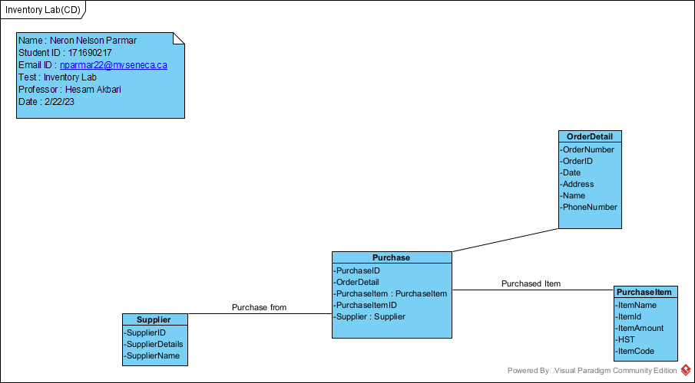

**Question 2.)**

**Sequence Diagram:-**

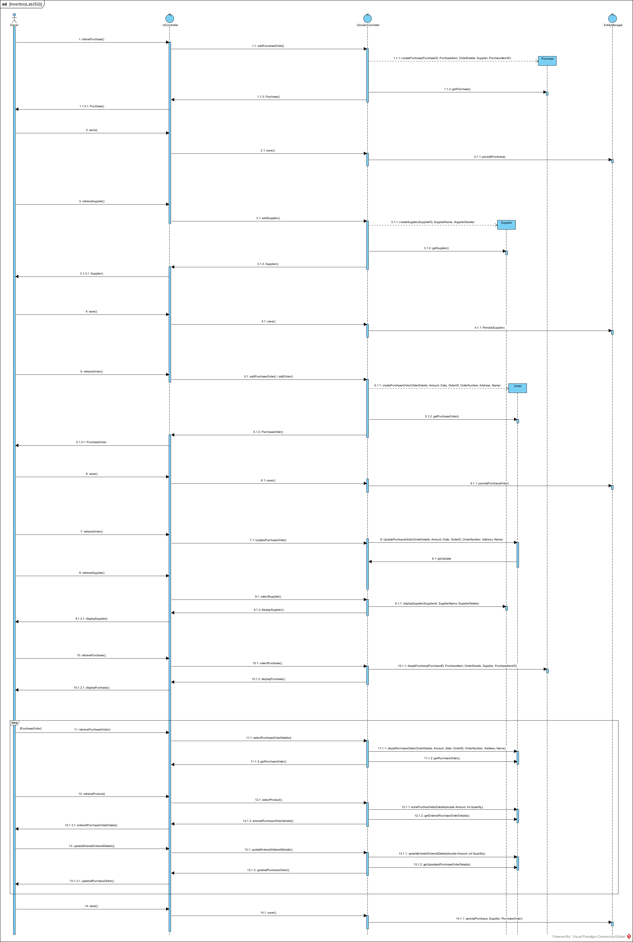

Question 3.)

Prototype of the Domain Controller:-

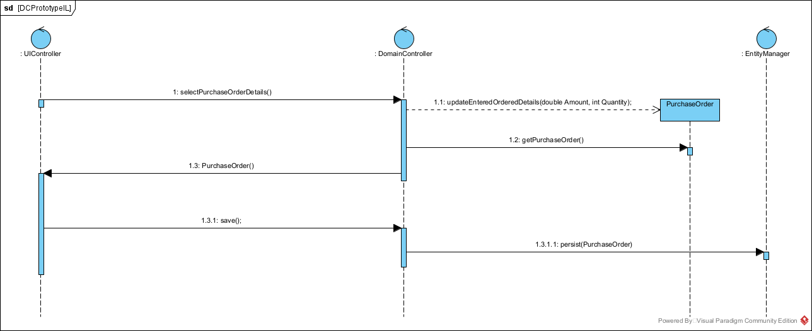

Question 4.)

If Bruce wants to find out or wants to know about the flies that how many he has in his inventory. We can make a sperate function called InventoryRack(); which will be a whole rack. And he can keep the count of the flies as there will be rack he can keep all the flies in the rack and can keep record of them. Apart from this if he wants to know the exact count of the flies he can simply use a method that, he needs to keep the flies that he sells everyday multiplied by the total remaining flies. We can make the separate function there will be a small change in our diagram however, it would be just add of function named as InventoryRack().